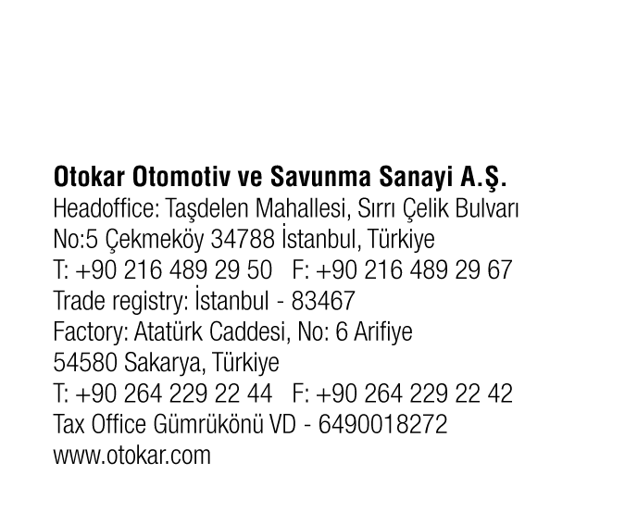


Press Release October 3, 2025

Otokar Continues to Grow Steadily in Europe

Otokar participated in Busworld Europe with its extensive bus range that reflects the future of public transportation. Continuing its steady growth in the European market, Otokar is showcasing seven vehicles, including electric and autonomous vehicles.

Otokar makes a strong presence at Busworld Europe, Europe's largest bus exhibition, held in Brussels, Belgium from October 4-9. The company exhibits seven vehicles, and showcases its strength in electric and autonomous vehicle technologies. Otokar has been experiencing consistent growth in the European market, with a focus on providing sustainable transportation solutions for operators and the environment.

At its stand Otokar exhibits the e-CENTRO, NAVIGO U Giga, ULYSO, e-KENT, and e-TERRITO models, while demonstrating its technological capability with the autonomous e-CENTRO and e-TERRITO in the outdoor area. The e-TERRITO is on display with different battery options. The 10.9 meter e-Kent bus is also being exhibited for the first time. Throughout the exhibition, visitors will be able to experience Otokar's autonomous e-CENTRO vehicle in the outdoor area.

STRENGTHENING ITS POSITION AMONG THE TOP 5 MANUFACTURERS IN EUROPE
Kerem Erman, Head of Commercial Vehicles, stated that the company is strengthening its position in Europe and provided information about its three main goals in the bus segment: “Otokar is making strong progress toward its three goals of becoming one of Europe's most modern and integrated bus manufacturing campus; strengthening sustainable growth in the European market; and modernizing its product range with a focus on electrification.”

“As Turkiye's first bus manufacturer, we have a 60-year legacy of excellence in bus manufacturing. Our expertise, production capabilities, and production technology have propelled us to become one of the top five bus manufacturers in Europe. In addition to the Otokar brand, our factory in Sakarya manufacture buses for two other global brands. Our current position demonstrates our quality and capabilities in production. We are ready for new partnerships thanks to our advanced technology, production capacity, and qualified human resources."

CONTINUOUS GROWTH IN EUROPE
Highlighting Otokar's success in Europe, Umberto Mauri, Co-Director of Otokar Italia said, "Today, more than 66,500 Otokar buses are on the road all around the world. We have made significant market gain in Europe recently. In line with our strategy we are continuing our growth. Our three largest markets in Europe are Italy, Spain, and France. It is also worth to mention that in Belgium which is home for Busworld we are enjoying a very strong market presence. We are intensively continuing our efforts to strengthen our presence in Germany and the Scandinavian countries. In parallel with the rapid growth in Europe, we have also reorganized our after-sales service structure."

ELECTRIFICATION AND AUTONOMOUS TECHNOLOGIES
Denis Toublanc, Marketing & Customer Service Director of Otokar Europe, mentioned about Otokar's efforts in electrification, saying: "We have shaped our strategies by taking customer expectations and supply risks into account. We offer different battery options for our electric vehicles. The electrification of our portfolio will continue in line with market expectations. On the other hand, we are continuing to increase our investments in autonomous technologies, which we have been researching and developing intensively for a long time. Our Autonomous e-CENTRO vehicle, developed entirely with our own engineering and software capabilities, has successfully passed TÜV Rheinland tests. We aim to be a pioneer in autonomous technologies in public transportation."

About Otokar
Otokar (BIST: OTKAR), established in 1963, offers solutions tailored to the needs of its customers using its own technology, design, and applications. Otokar, a Koç Group company, offers a diverse range of commercial vehicles, including buses, light trucks, and pickup trucks. Headquartered in Türkiye and operating with subsidiaries in France, Italy, Romania, the United Arab Emirates, and Kazakhstan and a branch office in Germany, Otokar exports its commercial vehicles to more than 50 countries worldwide.

Otokar, which offers a wide range of products from alternative fuel vehicles to autonomous vehicles, has been Türkiye's most preferred bus brand in public and tourism transportation for 16 consecutive years.

