Press release
19th September 2025
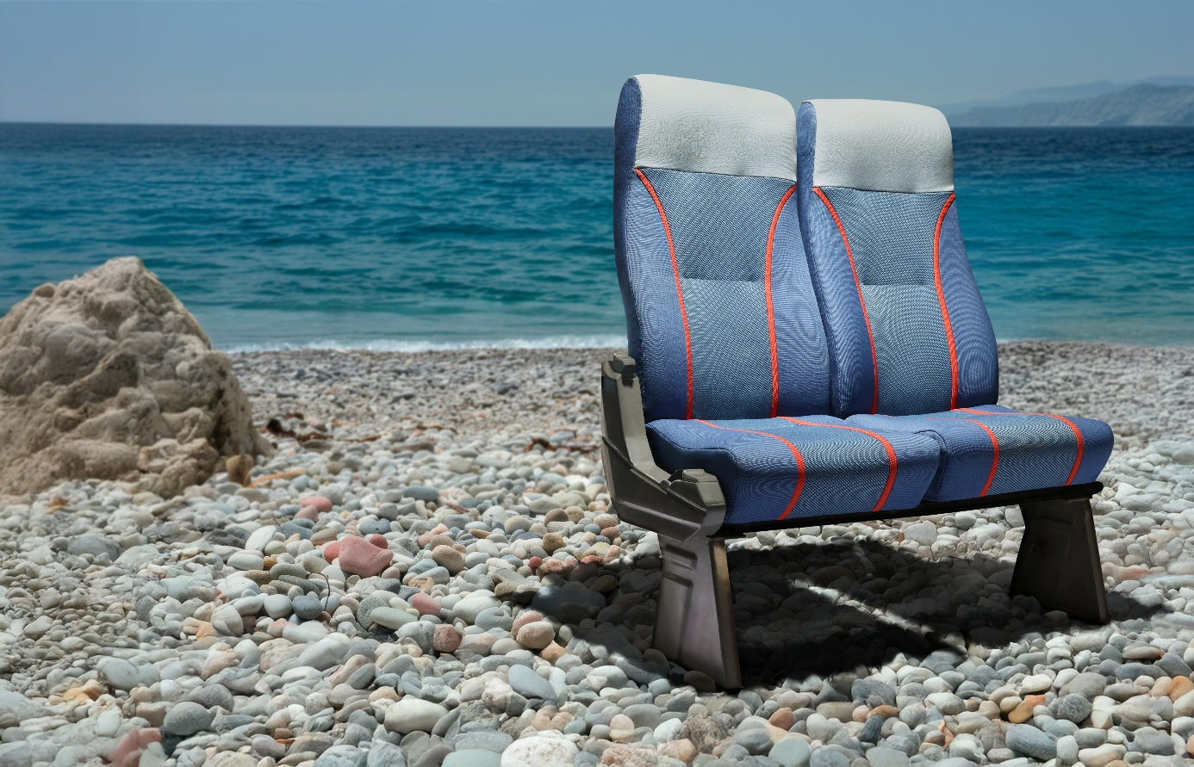

Turning the tide at Busworld: Camira hosts live Q&A with SEAQUAL INITIATIVE

Camira, the international textile manufacturer, will make a splash at Busworld 2025 with the launch of the transport industry’s first interior fabrics made from marine plastic waste. A highlight of the showcase will be a live talk and Q&A with François Devy, Managing Director of SEAQUAL INITIATIVE, on Monday 6th October at 5pm, Hall 4, Stand 420.

Created in collaboration with SEAQUAL INITIATIVE, a global community that transforms marine litter into textile solutions, Camira’s new SEAQUAL Collection features two lightweight, flat-woven fabrics: Oceanic and Quest. Each is made from SEAQUAL® Yarn, produced by recovering waste from oceans, rivers, and shorelines, which is woven into high performance recycled fabric.

At Busworld, François will share how SEAQUAL’s network of collection projects, from Tunisia’s Kerkennah Islands to Egypt’s Nile, creates both environmental and social value. He will also explore why transforming marine waste into yarn has the potential to change industries beyond textiles, and the urgent need for collaboration between manufacturers, operators, and consumers to tackle the global plastic crisis.

François Devy, Managing Director at SEAQUAL INITIATIVE commented: "Our collaboration with Camira is proving that sustainability and performance can go hand in hand. Unlike many recycled fabrics that use inland-sourced plastic, SEAQUAL targets waste already damaging marine ecosystems, creating greater environmental impact while also supporting local communities. I look forward to sharing more about our partnership at Busworld."

The SEAQUAL Collection not only diverts plastic waste from marine environments but also offers operators a sustainable fabric without compromise. It is 42% lighter than traditional wool transport fabrics, exceeds 100,000 Martindale cycles for durability, and incorporates Camira’s patent-pending Eco FR technology – a sustainable, halogen-free, flame-retardant backing.

Ciara Crossan, Head of Creative – Transport at Camira, added:
“François’ Q&A will bring the human and environmental story behind the SEAQUAL Collection directly to Busworld visitors. This is more than a new product - it’s a chance to rethink how we use resources and design for the future. We’re thrilled to have him join us to make change and have an impact.”

Join Camira and François Devy at Busworld 2025, Hall 4, Stand 420 at 5pm on Monday 6th October 2025 to discover how discarded plastics can be transformed into durable, stylish, and sustainable fabrics for bus and coach interiors.

ENDS
Notes to editors:

For more information, please contact:
Jennifer Ogden, PR, and Communications Manager
T: 07907181487 | E: jennifer.ogden@camirafabrics.com

About Camira:
Camira designs and manufactures textiles for every space and sector; from public transport, including bus, coach and rail to commercial and residential.

Camira is a privately-owned UK textile group founded in 1974 under the name Camborne Fabrics, but its heritage goes back to 1783 through various acquisitions.

Until a management buy-out in 2006, the company was a subsidiary of Interface, an international manufacturer of textile modular floor coverings, for almost ten years.

Today, Camira has an annual turnover of around £85 million and employs more than 600 people. Its products are sold in approximately 75 countries.

Headquartered in the UK, the company has manufacturing facilities in the UK and Lithuania, offices and showrooms in Europe, North America, Australia and China and a global network of agents and distributors.

The company has always been a pioneer in sustainable textiles, introducing its first recycled fabrics in the 1990s, as well as innovating a new category of fabrics made from natural wool and plant fibres, such as nettles, flax and hemp.

Find out more: camirafabrics.com

