to press@busworld.org

Press Release
PcVue Optimizes Electric Bus Charging with Its Advanced CSMS-SCADA Platform
Paris, France – 19/09/2025 – As public transport networks accelerate their transition to electric mobility, the need for robust, flexible, and secure charging management has never been greater. PcVue, developed by ARC Informatique, introduces an advanced CSMS-SCADA platform that ensures reliable charging, optimized energy usage, and reduced operational costs for electric bus fleet operators worldwide.
Vendor-Agnostic and Standards-Compliant
PcVue supports OCPP 1.6 and 2.0.1, enabling full interoperability across charging station brands. With its open architecture, the platform seamlessly integrates with third-party systems, utility interfaces, and value-added services, ensuring scalability and avoiding vendor lock-in.
Driving Operational Excellence
Through an intuitive interface, operators gain real-time visibility into fleet charging operations, monitoring key parameters such as state of charge (SOC), load duration, power delivered, and charging session status. Advanced diagnostics and alarm management reduce downtime with rapid fault detection and remote intervention.
PcVue also incorporates intelligent load balancing, helping operators reduce peak demand charges while keeping fleets fully ready for service.
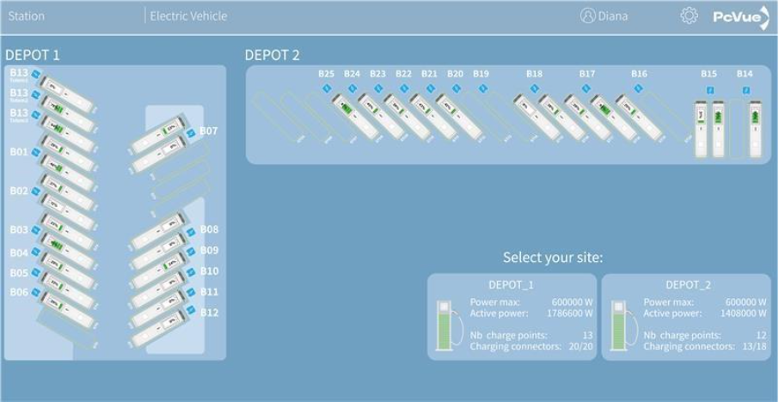

Safety and Maintenance at the Core
Integrated task scheduling, secure team communications, and contextual guidance streamline maintenance operations. Real-time battery temperature monitoring enhances safety by preventing thermal incidents, a critical aspect for high-capacity bus batteries.
Proven in the Field
The solution’s proven track record includes projects such as Jena’s e-bus fleet in Germany, where remote monitoring and advanced diagnostics significantly increased infrastructure availability. PcVue delivers a future-proof, standards-driven platform that meets the demanding needs of electric public transport operations.
About PcVue
PcVue, a solution by ARC Informatique, is a leading SCADA platform designed for energy and mobility applications. With a strong focus on interoperability, cybersecurity, and user experience, PcVue provides future-proof solutions for smart mobility, renewable integration, and digital transformation.
📌 Discover more: CSMS + SCADA PcVue
📌 Learn more at Busworld
Hall 11 / 1129

