
Ergonomics in the spotlight for Busworld 2025
~ Pailton Engineering to show specially created cabin demonstrator ~
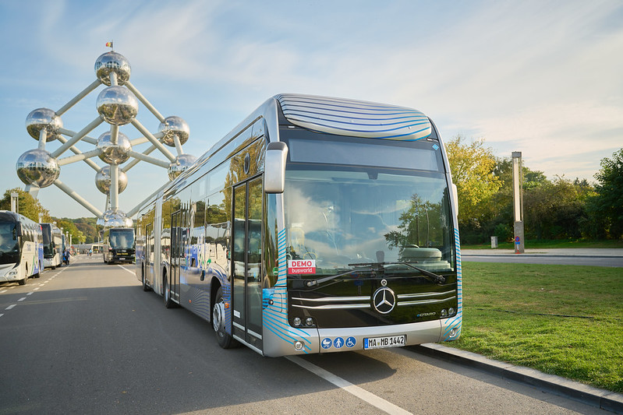
UK steering system manufacturer, Pailton Engineering, is exhibiting at Busworld in Brussels, on October 4-9, 2025. The company will unveil the commercially-ready version of its electric memory steering column, a pioneering product that represents a new standard in ergonomic design for the bus and coach sector. Visitors will be able to experience this technology first-hand in a specially built driver cabin demonstrator at Stand 936, Hall 9.

The prototype of the electric memory steering column was shown at Busworld 2023. Two years on, Pailton Engineering has developed this innovation into a commercially-ready product. This unique column allows for quick and precise adjustment between drivers, reducing musculoskeletal strain and helping operators to address the global driver shortage by improving working conditions.
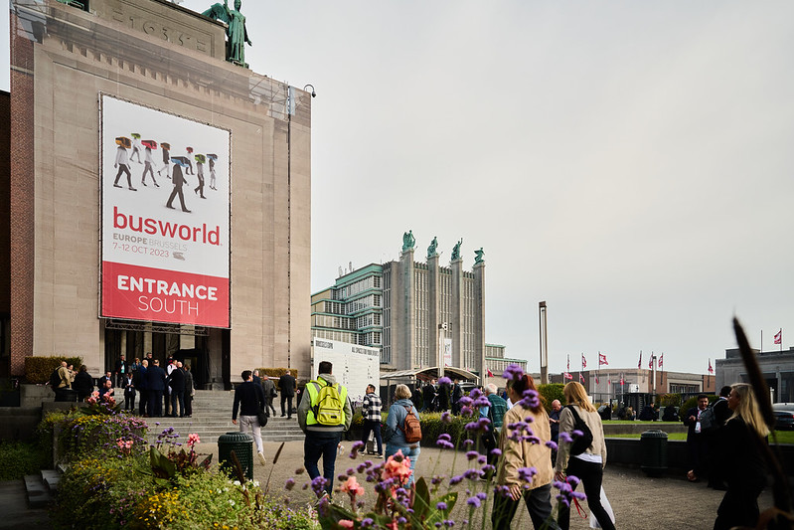
Visitors to the stand will be able to experience this innovative product in a driver pod, purpose-built to provide a demonstration of the future of bus cabin design. In addition to electronic adjustment, visitors will be able to see the column’s unique tilting head mechanism, first developed for the VDL Citea range of buses. With tilting head adjustment, the column is compliant with VDV 234 regulations, ensuring alignment with ergonomic standards for EU member states.

Visitors to the stand will also notice a bold new look for 2025. Pailton Engineering has deliberately adopted a louder and more striking stand design to ensure its message on ergonomics and driver wellbeing is heard across the industry.

“Bus driver cabins are often designed for the average person, yet drivers come in all shapes and sizes. As a result, many suffer from severe back pain and related health problems, while operators face the financial impact of increased sick leave and poor staff retention,” explained Roger Brereton, Head of Sales at Pailton Engineering. “Our columns address this challenge through superior ergonomic design that adapts to individual needs.”

The introduction of the electric memory column is a potential milestone in cabin design. “Two years ago we showed the industry a prototype. Now, operators can see and test the commercially-ready version, and experience how it transforms the driving environment,” added Brereton.

The Pailton team of engineers will be available on the stand to talk about the full range of steering solutions on offer. Alongside steering columns, the company designs and manufactures a complete range of steering components and systems, trusted by OEMs worldwide for their quality and custom-engineering expertise.

To book a meeting with the team ahead of visiting, please contact Pailton Engineering. You can contact Roger directly on rbrereton@pailton.com

Ends: 380 words

Image caption:
Editor’s note: If you want to ensure you keep up to date with all the latest news, opinion focussed content and case studies from Pailton Engineering, visit the company’s website here: http://pailton.com/latest-news

For further information contact: Roger Brereton
Pailton Engineering Ltd, Phoenix House, Holbrook Lane, Coventry, CV6 4AD
Telephone: +44 (0)2476 680445
www: http://pailton.com/
e-mail: Rbrereton@pailton.com

Press enquiries: Philip Morgan or Barney Hallawell – Stone Junction Ltd
Suites 1&2 The Malthouse, Water street, Stafford, Staffordshire, ST16 2AG
Telephone: +44 (0) 1785 225416
e-mail: philip@stonejunction.co.uk or barney@stonejunction.co.uk
www: www.stonejunction.co.uk
Blog: www.stone-junction.blogspot.com
Twitter: https://twitter.com/StoneJunctionPR
Facebook: http://www.facebook.com/technicalPR
LinkedIn: https://www.linkedin.com/company/stone-junction-ltd
About Pailton Engineering: Pailton Engineering Ltd design, test and deliver world class steering systems, using state of the art CAD (Solid Works), purpose designed and built test facilities, and state of the art manufacturing capability.

Ref: PAE673/09/25

