Optibus Expands GenAI Capabilities for Planning, Scheduling, Operating, and Optimizing Public Transportation

Optibus, the leading software platform for planning, operating, and optimizing public transportation, has introduced new capabilities to Optibus AI, the first Generative Artificial Intelligence (GenAI) suite purpose-built for public and private operators and agencies.

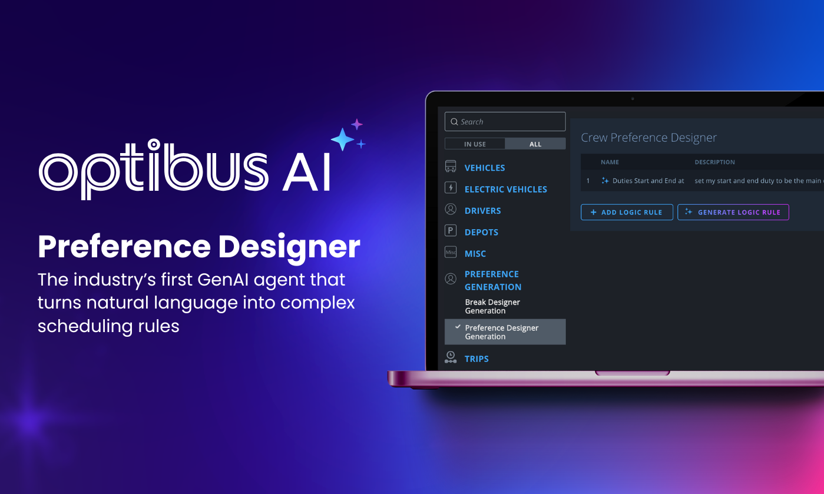

According to Optibus’ industry survey, 95% of public transportation enterprises have explored artificial intelligence, but only 8% noted measurable impact. Across industries, insufficient integration into existing workflows is a key cause of unsuccessful AI trials.

Unlike generic solutions, Optibus AI features a growing number of industry-specific AI agents fully integrated across the platform. Tools are embedded where and when transportation professionals need them most. With intelligence layers for every stage of work, agencies and operators can redefine planning, scheduling, and beyond with intuitive, platform-native capabilities.

Introducing the Optibus AI Agent for Preference Design

Preference Designer for Scheduling is the industry’s first Generative AI agent that uses natural language to create complex scheduling rules.

Building valid, optimized schedules that comply with complex business rules and union agreements has traditionally required configuration expertise and custom coding.

Optibus AI changes that.

Schedulers type preferences in plain language, such as “No more than ten duties over nine hours,” and Optibus instantly generates accurate, ready-to-use logic. No more specialized coding, configuration, or steep learning curves. Just fast, intuitive scheduling powered by AI.

Integrated with Optibus’ optimization engine and trained on real-world scheduling data, Preference Designer reduces errors and rule configuration time by up to 70%. It improves work quality with less effort, helps quickly onboard new users, and eliminates tedious, repetitive tasks. Planners and schedulers can easily build and test complex rosters while meeting compliance requirements.

Optibus AI: What’s Next

Additional AI agents are on the way, including:

- Schedule Analysis: Ask “What changed?” or “How does this affect cost?” to compare optimized scenarios, chart the best path forward, and persuade stakeholders with presentation-ready analysis and actionable insights.
- Multi-Step Automation: Skip multi-step processes by creating commands such as “Create a new scheduling scenario and electrify route 12 instead of 14.”
Amos Haggiag, CEO and co-founder of Optibus, said:
“Generative AI is kicking-off a new chapter in how public transportation is planned and operated. Optibus AI turns decades of complex processes into simple, intuitive tools that empower teams at every level.”

To learn more about Optibus AI, visit https://optibus.com/product/ai

###
About Optibus

Optibus is a unified, end-to-end software platform that cities and operators use to plan and operate public transportation networks. Our software unites all aspects of public transportation management - planning, scheduling, rostering, operations, real-time control, and passenger information - in one cloud-native platform and uses artificial intelligence (AI), cloud computing, and optimization algorithms to assess thousands of potential service scenarios. Through optimized decision-making, our users in more than 7,000 cities in 35 countries are improving their operational efficiency, enhancing the passenger experience, promoting transportation equity, reducing emissions, cutting costs, and modernizing their operations. Learn more: www.optibus.com

