Off-road Vehicle Braking System Market Size Worth USD 4.37 Billion by 2034 | CAGR: 9.8%
The popularity of adventure sports and construction equipment is on the rise globally. As such, the off-road vehicle braking system market is gaining momentum. Braking systems designed for off-road vehicles need to withstand rugged terrain and challenging environmental conditions. They must also ensure the safety of drivers and passengers. As the demand for high-performance and reliable braking solutions increases, the market is witnessing advancements in safety integration.
Types of Off-Road Vehicle Braking Systems
Hydraulic Braking Systems
Hydraulic brakes are among the most widely used systems in off-road vehicles. This is because they offer consistent and powerful braking force. These brakes make use of fluid pressure to transfer force from the brake pedal to the wheel cylinders. They offer smooth and responsive braking, which is essential when navigating steep slopes and rocky trails.
Disc Brakes
Disc brakes are becoming a popular choice in modern off-road vehicles. This is because they perform well under extreme conditions. They make use of a brake rotor and caliper system. The system allows for better dissipation of heat and reduces brake fade during prolonged use. The ability of these brakes to maintain performance in different terrains makes them suitable for off-road sports and utility vehicles. Additionally, the inspection and servicing of disc brakes is easier compared to drum brakes.
Drum Brakes
Drum brakes are considered more traditional. However, they are still used in certain off-road applications. These brakes are known for their simple design. They are also cost-effective. They are suited for rugged environments where maintenance infrastructure may be limited. However, their heat dissipation capabilities are low.
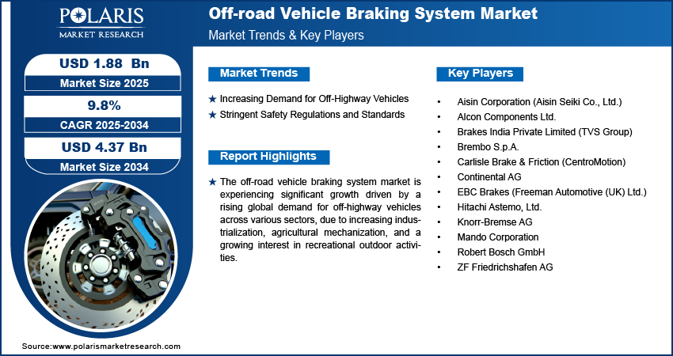
Electro-Hydraulic Braking Systems
These brakes combine the benefits of hydraulics and electronic control mechanisms. They offer precision braking and integration of advanced safety. They are especially useful for heavy-duty off-road vehicles such as mining trucks. They allow electronic modulation of hydraulic pressure. So, they can support features such as traction control and anti-lock braking systems.
Market Metrics
- The off-road vehicle braking system market is expected to witness robust growth, according to the latest analysis by Polaris Market Research.
- The market was valued at USD 1.72 billion in 2024.
- It is projected to grow to USD 4.37 billion by 2034.
- The market is expected to exhibit a CAGR of 9.8% from 2025 to 2034.
Market Growth Drivers
Rising Popularity of Recreational Off-Roading
Recreational off-roading has become a major outdoor activity. Adventure tourism and organized motorsport events are driving the adoption of vehicles that are designed for rugged terrain. These vehicles require specialized braking systems capable of withstanding the harsh conditions of rugged terrains. This has created increased demand for brakes that are highly durable. Manufacturers are responding to this with a performance-oriented system. These systems help ensure safety and also enhance the confidence of the rider when performing extreme maneuvers.
Construction and Agriculture Expansion
Heavy-duty off-road vehicles are being increasingly used across sectors such as agriculture and mining. These vehicles operate under harsh conditions. They often carry or pull loads across surfaces that are uneven. In these environments, braking efficiency has a direct correlation with the safety of workers and the reliability of operations. This is driving demand for braking systems that can handle high torque and heavy loads.
View More Information @ https://www.polarismarketresearch.com/industry-analysis/off-road-vehicle-braking-system-market/request-for-sample
Safety Regulations and Standards
Governments and regulatory bodies are imposing stringent safety guidelines for off-road vehicles. These guidelines aim at reducing accidents and improving reliability. Standards related to braking distance and fail-safe mechanisms have encouraged manufacturers to go with advanced technologies. The regulatory push is improving consumer safety. It is also driving demand for upgraded braking systems across vehicle categories.
Emerging Market Trends
ABS and Traction Control Integration
Anti-lock braking systems (ABS) and traction control are being increasingly integrated in modern off-road vehicles. These technologies help in preventing the lock-up of wheels and loss of control on slippery tracks. Automatic adjustment of braking force and distributing torque helps enhance vehicle handling during steep climbs.
Lightweight Materials
Manufacturers are increasingly using aluminum alloys and composite materials in brake system components. They are using these materials to meet the growing demand for fuel efficiency and performance. Lightweight materials help reduce the overall weight of the vehicle. They also improve braking responsiveness and durability under extreme conditions.
Conclusion
The off-road vehicle braking system market is poised for significant growth. Rising recreational off-roading and the expansion of construction and agricultural machinery are driving market demand. The market is expected to witness the introduction of more advanced braking systems in the coming years.
Read More @ www.polarismarketresearch.com

