CASTROSUA GROUP LAUNCHES NEW ELECTRIC COACH AT BUSWORLD
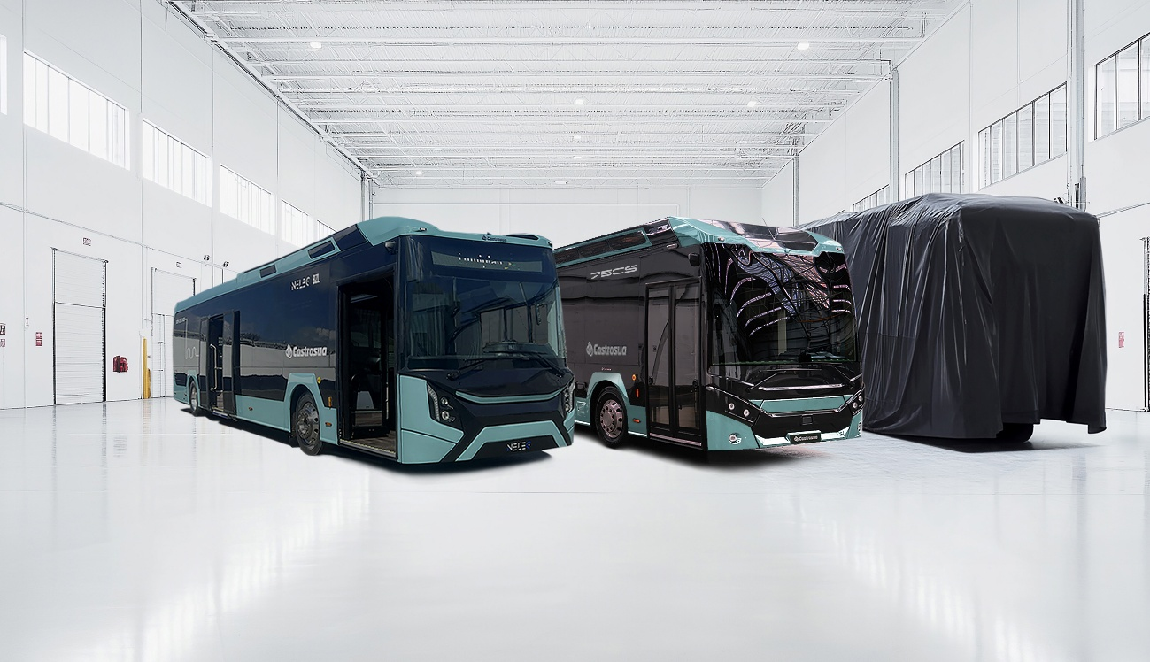
Santiago de Compostela, 18/09/2025 – The Castrosua Group will attend the next edition of the Busworld international trade fair, which will take place in Brussels. At its stand located in Hall 8, number 804, it will showcase a solid and diverse range of products, reinforcing its position in innovation and sustainability. The company will bring a sample of its latest offerings for the three market segments: urban, commuter and long-distance, all of them in electric versions.
Castrosua is taking advantage of this edition to launch its new electric Coach, a first for the brand, which reaffirms its commitment to this segment by tackling a different vehicle concept. This first unit is presented in an electric version, on a Volvo BZR chassis, although the model will be available in all types of propulsion. True to its DNA, the group is committed to cutting-edge innovation with a product that completes its wide range of mobility solutions. The company will reveal all the details at its launch on 6 October at Busworld.
Alongside this new model, Castrosua will also be showcasing a 12-metre NELEC, its 100% electric solution for urban transport, and a 13-metre 75 CS Low Entry, thereby consolidating its offering in the intercity segment and completing its range of mobility solutions for classes I, II and III.
With these three units, Castrosua continues to demonstrate its commitment to sustainable mobility, technological innovation, and proximity to operators and users by offering specific solutions tailored to the real needs of passenger transport and the demands of the global environment in which it operates.

