Karsan Autonomous e-ATAK Era Begins in Autonomous Public Transportation in Sweden!

Karsan Autonomous e-ATAK Will Connect Gothenburg Central Station to Liseberg Station!

Autonomous Public Transportation Begins in Sweden with Karsan Autonomous e-ATAK!
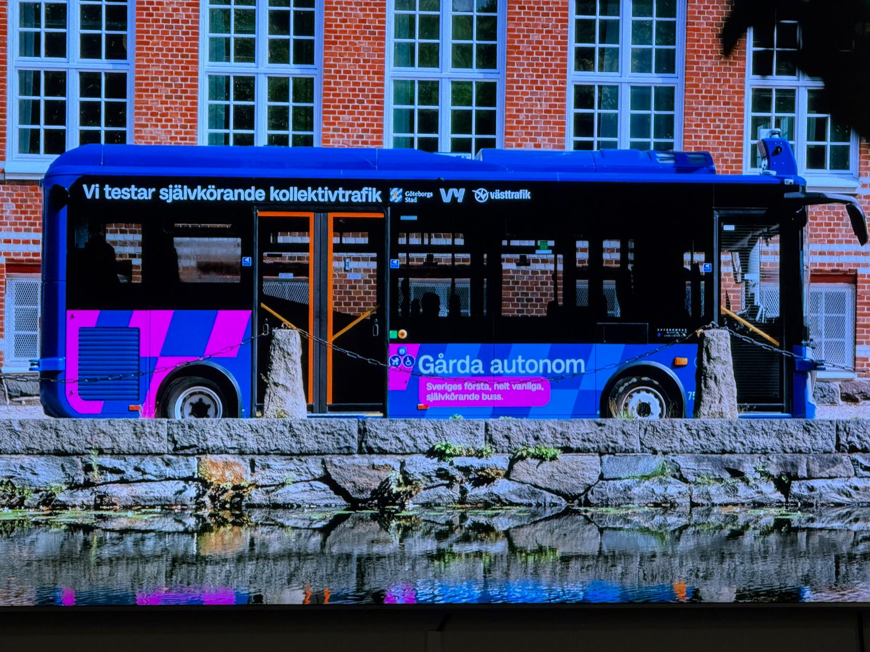

Karsan, a global brand with a vision of “Staying One Step Ahead in the Future of Mobility,” has added another achievement to its worldwide successes. In this context, Karsan Autonomous e-ATAK, the world's first Level 4 series-produced autonomous bus, has begun service in Sweden. Karsan Autonomous e-ATAK, which has started carrying passengers in open traffic, will connect Gothenburg Central Station to Liseberg Station and provide a seamless and efficient transportation solution in the city's Gårda district. Karsan CEO Okan Baş said that this project represents a new milestone in Karsan's journey to redefine public transportation, adding, "The project involves a highly complex route operating under real traffic conditions in the city center. This is not only a testament to Karsan's engineering capabilities but also a significant contribution to Sweden's future mobility ecosystem. Overcoming challenging operational conditions, including Scandinavia's harsh climate and dynamic city traffic, Autonomous e-ATAK will offer passengers a unique experience centered on comfort, safety, and reliability.

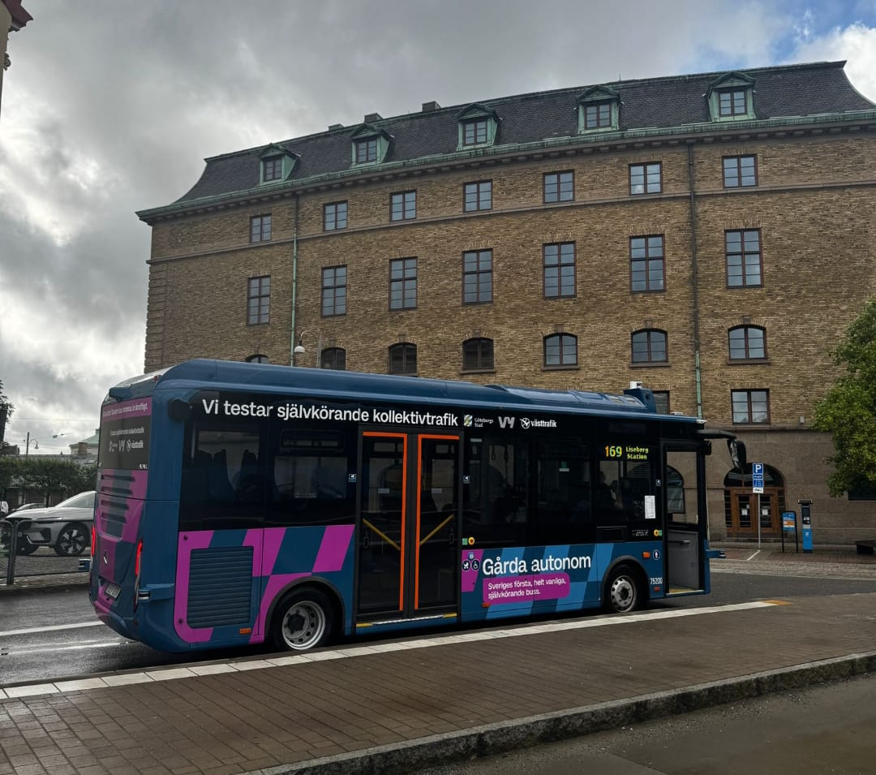

Karsan, a pioneer in the global transition of public transportation to electric and autonomous vehicles, continues to spearhead innovative projects in the industry with its cutting-edge technologies. Having become a global brand through its successful projects spanning a wide geography from Japan to the United States, Karsan serves customers with over 2,000 electric vehicles deployed across 27 countries. In this context, Karsan Autonomous e-ATAK, the world's first Level 4 autonomous electric bus developed by Karsan in collaboration with its technology partner ADASTEC, has begun transporting passengers in the Swedish market.
Sweden has transitioned to seamless and efficient transportation!
Karsan Autonomous e-ATAK, which began passenger transport at an event held in Gothenburg, Sweden, and was previously delivered to Vy Buss, one of Northern Europe's leading Public Transport Authorities (PTA), will now operate in collaboration with Sweden's leading public transport operator Västtrafik, under Vy Buss. Following the ceremony, Karsan Autonomous e-ATAK drove on public roads along a 4-kilometer route with 7 stops connecting Gothenburg Central Station and Liseberg Station. The Karsan Autonomous e-ATAK will connect Gothenburg Central Station to Liseberg Station and provide a seamless and efficient transportation solution in the city's Gårda district. Karsan CEO Okan Baş said that Karsan Autonomous e-ATAK is a Level 4 autonomous vehicle that has started carrying passengers in Sweden's real traffic conditions, adding, "In this context, our vehicle will start a one-year operation in Gothenburg, one of Sweden's most strategically important cities, in cooperation with Västtrafik. This represents another milestone in our company's journey to redefine public transportation."

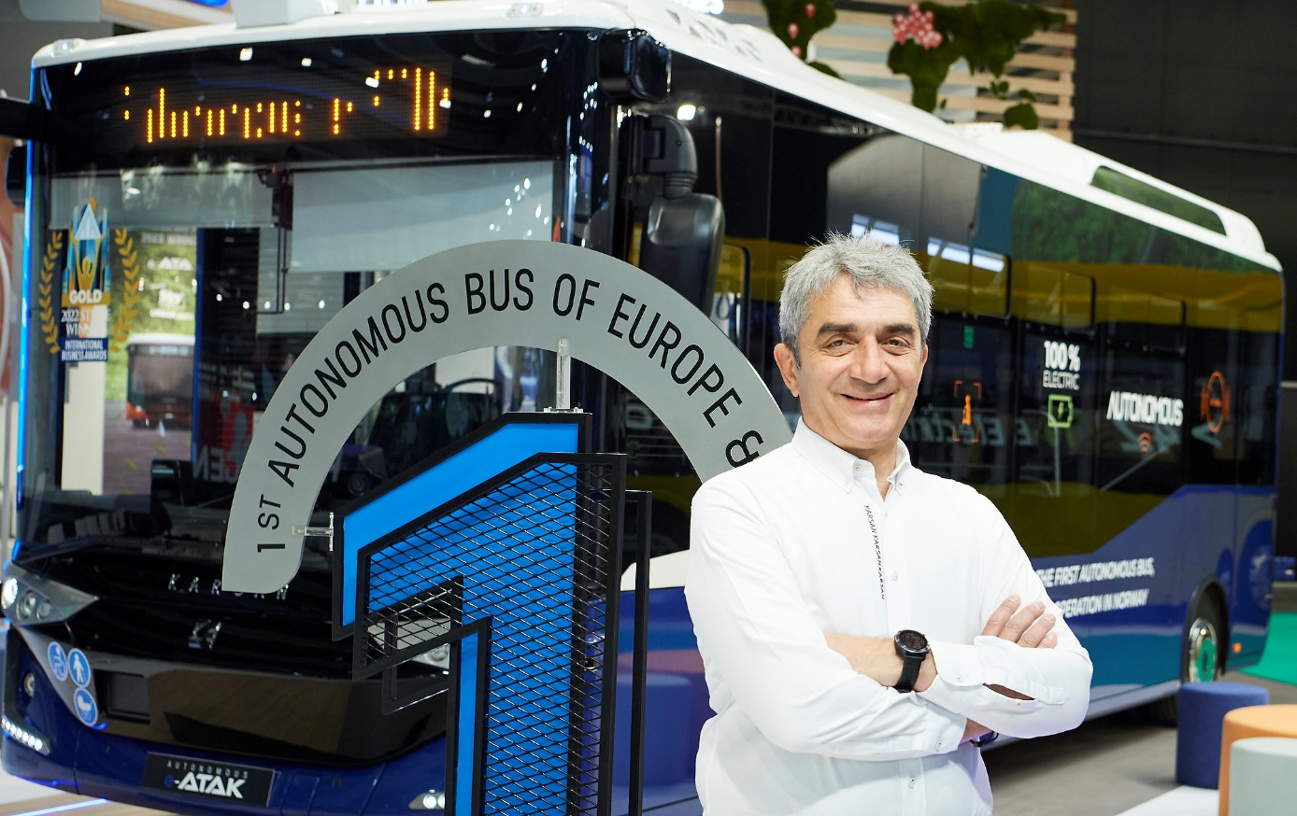

Dr. Ali Peker, CEO of ADASTEC, the technology partner of Karsan Autonomous e-ATAK, made the following comments on the subject: "The Level-4 public transportation service we offer in different cities and countries around the world in collaboration with Karsan proves the maturity and reliability of our technology. The Autonomous e-ATAK, which has been put into service in Gothenburg, is designed to withstand harsh weather conditions and the complexity of urban traffic, offering a safe and seamless journey with ADASTEC's Level-4 autonomous driving technology. At each new stop, we are not only transporting people, but also sustainable cities and inclusive public transportation into the future. Our goal is to transform autonomous public transportation services into a meaningful service that meets today's needs and will be passed on to tomorrow's societies.

A new step in our global leadership vision!

Emphasizing that the project involves a highly complex route operating under real traffic conditions in the city center, Karsan CEO Okan Baş said, "This application is not only a demonstration of Karsan's engineering capabilities, but also a significant contribution to Sweden's future mobility ecosystem. Overcoming challenging operational conditions, including Scandinavia's harsh climate and dynamic city traffic, the Autonomous e-ATAK will offer passengers a unique experience centered on comfort, safety, and reliability. This groundbreaking project is the result of a strong partnership between Karsan and ADASTEC, which provides the vehicle with advanced automation technology. With this partnership, Karsan continues to set new standards in autonomous transportation and shows the world how innovation, flexibility, and vision can reshape public transportation. With this project implemented in Sweden, Karsan is not only strengthening its position in Northern Europe's most advanced transportation market but also taking another step toward achieving its vision of becoming a global leader in sustainable transportation. We would like to thank Västtrafik, Vy Buss, and the City of Gothenburg, who played a significant role in bringing this project to life, as well as our technology partner ADASTEC," he said.

Karsan Autonomous e-ATAK is always ready for service!

Equipped with an Advanced Sensor Package, Karsan Autonomous e-ATAK uses a combination of LiDAR, Radar, RGB Cameras, GNSS, and the latest technology sensors working together to provide precise navigation and situational awareness in different weather conditions. With a 220 kWh battery pack and a length of 8.3 meters, the Karsan Autonomous e-ATAK stands out as a sustainable, high-capacity transit solution capable of efficiently meeting Gothenburg's urban transportation demands. The bus's ability to fully charge in 5 hours with AC units and 3 hours with DC units ensures the vehicle is always ready for service.

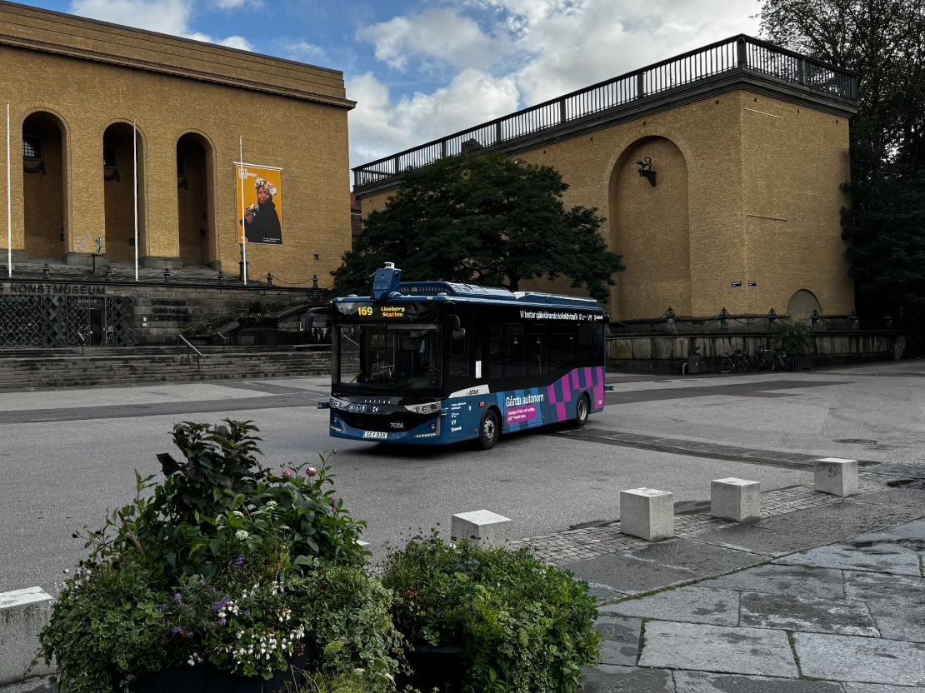

About Karsan:

Leaving 59 years behind in the Turkish automotive industry, Karsan has been producing for the world's leading brands in the commercial vehicle segment, including its own brand, in its modern facilities since the day it was founded. Producing commercial vehicles since 1981, Karsan's factory in Hasanağa, Bursa, has the capacity to produce ~20 thousand vehicles in a single shift per year. Designed with the flexibility to produce all kinds of vehicles from passenger cars to heavy trucks, from minivans to buses, Hasanağa Factory is 30 km away from Bursa city center and is located on a total area of 203 thousand square meters, 99 thousand square meters of which is closed.

As the only independent multi-brand vehicle manufacturer in the Turkish automotive industry, Karsan aims to take part in all segments of passenger transportation by developing derivatives of new and existing products together with its business partners and licensors in line with its vision of being one step ahead in the future of mobility. Continuing its activities to develop and market "innovative products and services" in the public transportation sector "from idea to market", Karsan aims to strengthen its Main Manufacturer/OEM business line in particular.

Continuing its activities of developing and launching "innovative products and services" in the public transportation sector, from "intellectual development to market", Karsan aims to strengthen its main manufacturer/OEM business line in particular. Karsan manages the entire automotive value chain, from R&D to production, from marketing to sales and after-sales activities. Karsan manufactures Jest and Atak models under its own brand. Developed in collaboration with Karsan e-JEST in 2018, Karsan e-ATAK in 2019, and the domestic technology company ADASTEC in 2021, the Level 4 driverless bus Autonomous e-ATAK, which is a first in the world, launched the 10m, 12m, 18m models of the born electric e-ATA family in the same year and e-ATA HYDROGEN models in 2022, becoming the first and only company in Europe to offer an all-electric product range from 6 meters to 18 meters. As of 2022, Karsan also produces Megane Sedan cars for the Renault brand, and at the end of 2023, it became the first European bus manufacturer to enter the Japanese market with the right-hand drive e-JEST model.

