Hispacold launches first serial production of HVAC systems with natural refrigerant R290 for public transport
Hispacold has reached a major milestone in the public transport air conditioning sector with the launch of the first serial production of HVAC systems using natural refrigerant R290. This innovation addresses the growing environmental challenges and complies with the new European F-Gas Regulation (EU Regulation 517/2014), which drives the transition toward low-impact, sustainable refrigerants.
With more frequent and intense heatwaves, along with increasingly unstable and extreme winters, the demand for high-performance, energy-efficient HVAC systems has never been greater.
In response, Hispacold launched a multi-year R&D program in 2023, focused on sustainability, energy efficiency, and the digital transformation of passenger comfort in public transport. A strategic investment of €6 million was made to accelerate innovation and completely redesign HVAC systems from the ground up.
The new range for R290-based system has been developed for both electric buses and rail vehicles, with the first deployment planned in Germany. This marks a significant step forward for Hispacold, positioning the company as a leader in the bus HVAC industry by bringing an R290 solution into serial production in Q4 2025, while meeting the highest standards in safety, performance and passenger comfort.
Key Advantages of the e- bus R290 Heat pump HVAC Systems
- Guaranteed sustainability: Uses a natural refrigerant with a Global Warming Potential (GWP100) of just 3 — fully aligned with European regulations and global climate policies.
- Maximum safety and reliability: Engineered for the safe use of A3 refrigerants, fully compliant with the most demanding European standards an guide line.
- Scalable and efficient design: Maintains the same footprint as conventional HVAC systems, with a modular architecture adaptable to various vehicle types and climate conditions.
- Smart thermal management: Advanced control software enhances energy efficiency, extends driving range, and ensures optimal passenger comfort.
- Lower Total Cost of Ownership (TCO): Simplified maintenance, use of standard components, and reduced dependency on single-source suppliers.
SIGNUM: AI-Powered Predictive Maintenance
Hispacold complements this innovation with SIGNUM, its proprietary AI-based predictive maintenance system for public transport HVAC. Unlike generic platforms, SIGNUM continuously learns from the real-world operating profile of each vehicle, delivering accurate diagnostics, early fault detection, and actionable maintenance insights.
The system helps reduce unexpected failures, improve energy efficiency, extend component lifespan, and keep HVAC systems operating at peak performance — ensuring comfort, reliability, and operational savings for fleet operators.

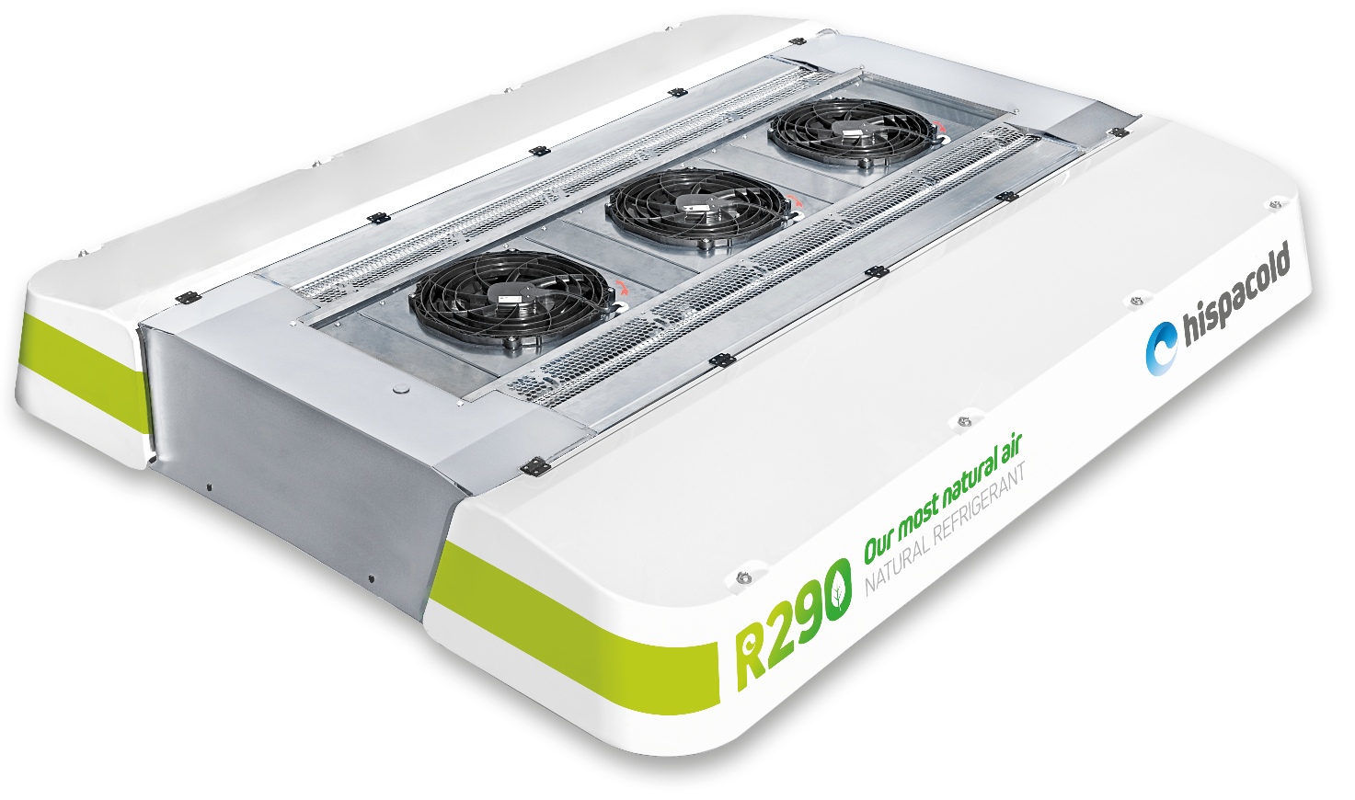
e-bus Heat Pump R290 HVAC

