Altertek to Showcase Battery Regeneration Technology at Busworld Brussels 2025
Regenerating the future of transport through sustainable hybrid and electric bus solutions

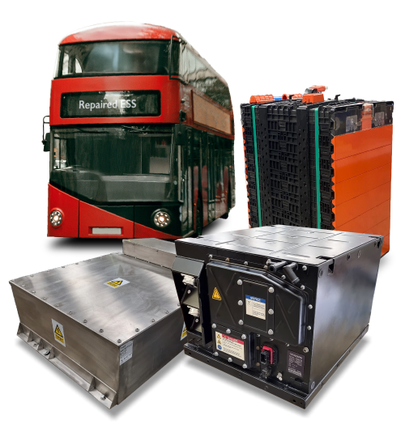

Altertek Ltd., a UK-based leader in battery regeneration and monitoring technology, will debut at Busworld Brussels 2025, unveiling its innovative approach to extending the life of hybrid and electric bus batteries.
With the growing demand for zero-emission public transport, many operators face the high cost and environmental burden of replacing bus batteries after just a few years in service. Altertek addresses this challenge by regenerating existing batteries, which extends the life of the ESS. They also provide state of health assessments and fault investigations, delivering lower costs, reduced waste, and improved fleet reliability.
Altertek’s expertise covers a wide range of leading ESSs, including Volvo B5LH hybrids, BAE Systems, Microvast, and BYD platforms. Already working with major UK bus depots, Altertek is excited to be expanding across Europe and beyond in order to help extend the life of these batteries and most importantly keep vehicles on the road.
“Our mission is simple: to regenerate the future of transport by making electric and hybrid fleets more sustainable and affordable,” said Rob Hart, Managing Director of Altertek. “Busworld is the perfect platform to connect with operators and manufacturers across Europe who share that vision.”
Visitors to Busworld Brussels 2025 can meet the Altertek team and experience their solutions in Hall 3, Stand 308.
About Altertek
Altertek Ltd. is a specialist in hybrid and electric bus battery regeneration. The company extends battery life through advanced cell rebalancing and offers remote monitoring systems that improve fleet performance. Working with leading UK operators, Altertek is now expanding into Europe and beyond, with a mission to regenerate the future of transport.
Contact Details:
Email: marketing@altertek.com

