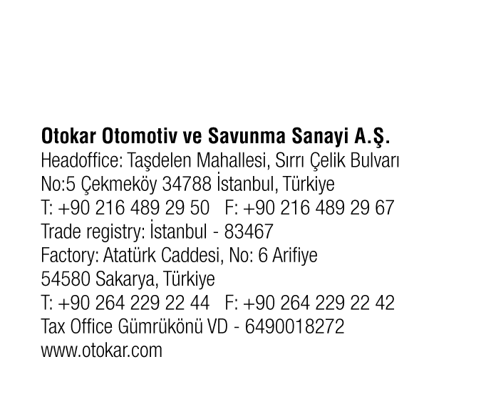


Press Release September 11, 2025

Otokar and Daimler Buses Sign Production Agreement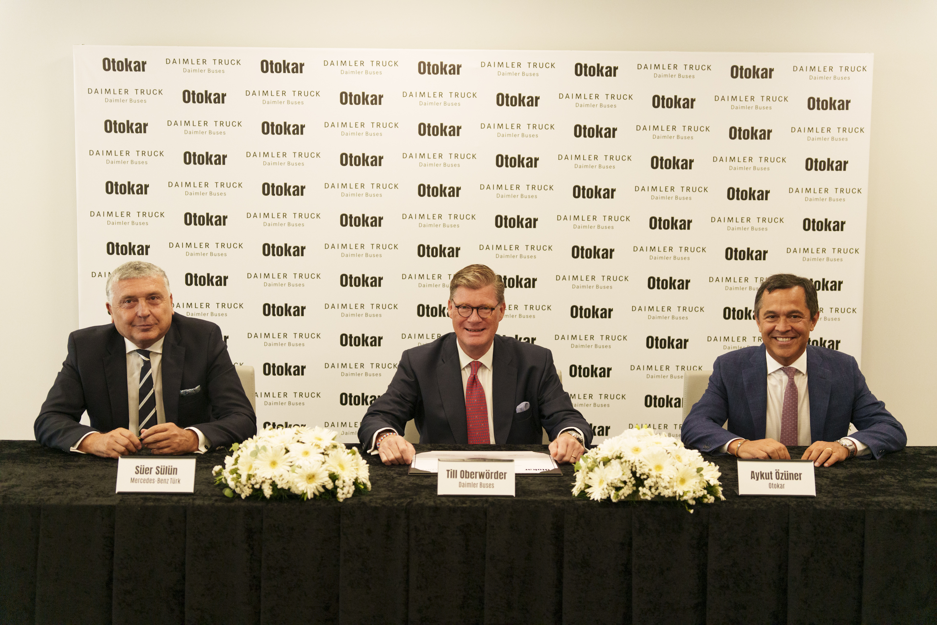
Türkiye's leading automotive manufacturer Otokar and global bus manufacturer Daimler Buses have signed an agreement for the production of Mercedes-Benz Conecto buses at Otokar's factory in Sakarya.
Otokar, a Koç Group company, will produce the conventionally powered Mercedes-Benz Conecto city bus for Daimler Buses at its plant in Sakarya, Türkiye starting from September 2026. Till Oberwörder, CEO of Daimler Buses, Süer İsmail Sülün, President & CEO of Mercedes-Benz Türk A.Ş, and Aykut Özüner, CEO of Otokar, signed the agreement today in Sakarya.
Aykut Özüner: “As Turkey's first bus manufacturer, we have been producing high-quality buses for over 60 years. The partnership with Daimler Buses is a significant step for us to further in expanding our production, ensuring the most effective use of our production capacity, and strengthening our position as one of the top five bus manufacturers in Europe. Our goal with this agreement is to establish a sustainable partnership with Daimler Buses.”
Till Oberwörder: “The ongoing strong demand for our products shows that buses are becoming increasingly important to society and that we are offering our customers the right solutions. We are the clear market leader in Europe and Latin America – and this cooperation allows us to further strengthen our position by increasing overall vehicle production. Expanding our production capacity has a positive impact on our profitability. Otokar is a highly respected and reliable partner in our industry with strong manufacturing expertise. Working closely together, we will ensure the high-quality standards our customers expect from Daimler Buses. We look forward to this partnership.”
Süer Sülün: “We are delighted by the strong demand for our buses and the resulting very positive order situation at our Hoşdere plant. The site is a key part of Daimler Buses’ production network and continues to manufacture buses across all segments. We at Mercedes-Benz Türk welcome the partnership with Otokar and are very much looking forward to supporting this collaboration as a strong and reliable partner.”

About Otokar
Otokar (BIST: OTKAR), established in 1963, offers solutions tailored to the needs of its customers using its own technology, design, and applications. Otokar, a Koç Group company, offers a diverse range of commercial vehicles, including buses, light trucks, and pickup trucks. Headquartered in Türkiye and operating with subsidiaries in France, Italy, Romania, the United Arab Emirates, and Kazakhstan and a branch office in Germany, Otokar exports its commercial vehicles to more than 50 countries worldwide.

Otokar, which offers a wide range of products from alternative fuel vehicles to autonomous vehicles, has been Türkiye's most preferred bus brand in public and tourism transportation for 16 consecutive years.

About Mercedes-Benz Türk A.S.
Mercedes-Benz Türk has been operating in Türkiye for 58 years as an integral part of Daimler Buses production network. Mercedes-Benz Türk has produced more than 113,000 buses and around 400,000 trucks since its establishment. Since its opening in 1995, Hoşdere Bus Plant—the largest bus production site of Daimler Buses globally—has made significant contributions to Daimler Buses’ global operations. Today, covering an area of 415,000 square meters, it continues to operate confidently as a key manufacturing hub in Türkiye. Mercedes-Benz Türk Hoşdere Bus Plant continues production with a wide range of models.

About Daimler Buses
As one of the world’s leading bus and coach manufacturers with numerous national subsidiaries, the Daimler Truck segment Daimler Buses is responsible for the global activities of the bus, coach and service brands Mercedes-Benz, Setra, OMNIplus and BusStore. The portfolio of Daimler Buses ranges from coaches, inter-city buses, city buses and special-purpose buses to bus chassis. In addition to the production and sales of new buses, Daimler Buses operates a global service network and offers comprehensive services for vehicles and used buses and coaches.

The locations of Daimler Buses include Daimler Buses GmbH with numerous subsidiaries in Europe, Daimler Buses Latin America in Brazil, Daimler Buses Mexico, Daimler Coaches North America and the bus and coach business of Mercedes-Benz Türk A.Ş in Türkiye.

Daimler Buses relies on a production network with its two German plants, Mannheim and Neu-Ulm, playing central roles: The Mannheim plant serves as the competence center for battery-electric city buses, while the Neu-Ulm plant is the competence center for coaches of all drive types and the sole production site for Setra coaches. Further plants within the production network are located in Ligny-en-Barrois, France; Samano, Spain; and Hoşdere, Türkiye.

